# Why did students choose Barcelona – and what are their complaints?

# Olga Makeeva, Peter the Great St.Peterburg Polytechnic University, Russia

# Abstract

The topic of complex networks is finding more and more applications. The paper presents a complex network of the connection students (from different countries) and their reasons to study in Barcelona. This study involved 38 students from different countries currently studying in Barcelona. Two surveys were conducted: the first to find out the reasons that prompted them to choose Barcelona for study, the second to clarify the points that they did not like after a while. After creating networks we analyzed it with NodeXL.

# Key words:

Network, study abroad, NodeXL

# Introduction

Examples include the Internet, a collection of computers linked by data connections, and human societies, which are cluster of people linked by acquaintance or social interaction. [1]. The educational system is not an exception, the connection between the choice of university for different categories of people is particularly interesting to universities and for organizations that provide students with the opportunity to study in different countries. This report investigates the network of reasons for choosing Barcelona as a city for study for exchange students. The aim of the research was to analyse the connection between students from different countries when they choose the city for study. Questions about how students from one country (region) are connected when they choose Barcelona as a city for study, what motivates or demotivates students after a period of study in Barcelona. Studied topic has allowed us to understand the reasons for the selection, to confirm some of the features inherent to certain countries (regions), as well as open new ones.

# Methodology

## Object of study

This study analyzes the network of the main reasons for choosing Barcelona by students from different countries, were involved 38 students from 14 countries, currently studying in Barcelona. In the first approach of analysing the survey networks were created where the individual participants are represented by their country as a node. The edges displayed the strength of the connections between the individuals due to their matching answers. The idea was to find a systematic connection between answers and countries. For example, those individuals from cold countries choose Barcelona because of the weather. However, the answers of the participants from a certain country were not as similar as expected. Moreover, except Germany, France and Italy all the other countries had three or less participants which makes the results not reliable. All these issues lead to a second approach of analysing the data where countries with less than three participants where merged to regions like BeNeLux, Scandinavia and East Europe. This approach promised more reliable data and provides a better overview. Furthermore, the answers of the only participants of Argentina and Turkey were sort out because they didn´t fit into one of the regions. Figure 1 shows the total number of students surveyed, and also grouped according to the region of residence of the respondent, to conduct a correct analysis.

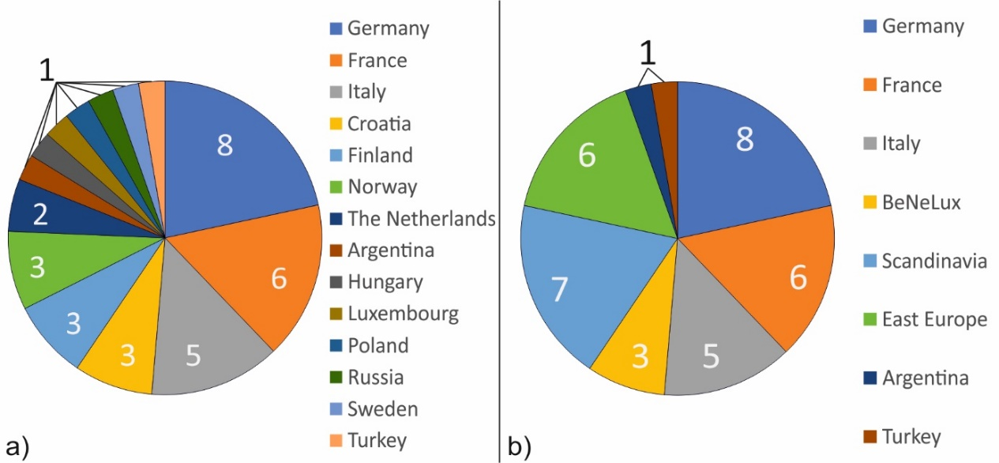

Figure 1: a) Participants (countries); b) Participants (regions)

Two categories of nodes are used in this network analysis:

1. Regions to which respondents belong;
2. Answers from the proposed list.

## Survey

To determine the reasons why students choose Barcelona as their destination for the study abroad a survey was created and conducted. The survey was separated in two parts. The first had answers to the question “reasons you´ve picked Barcelona” (Likes) while in the second part the question “what do you dislike about the city since you came here” (Dislikes) should be answered. In both parts it was only possible to pick an answer or not. The possible answers were separated in the four following categories:

* Geographical location
* Culture and people
* Social life
* Education

Given that two surveys were conducted: the first, the reasons for choosing Barcelona *(Figure 2)*, and the second, what disappointed in choosing *(Figure 3)*, the two networks were grouped, both networks are bi-partite and were drawn using NodeXL template.

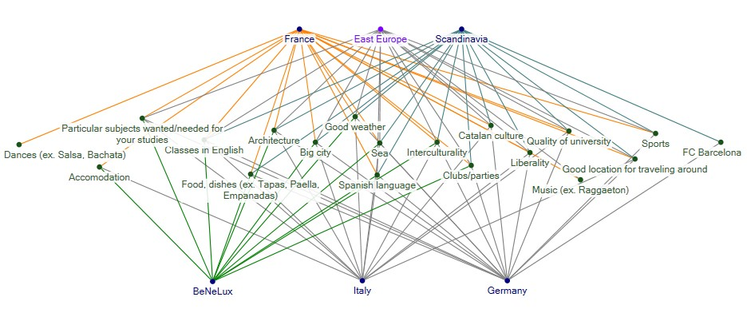

Figure 2: Visual representation of the initial bi-partite network: “reasons you´ve picked Barcelona” (Likes)

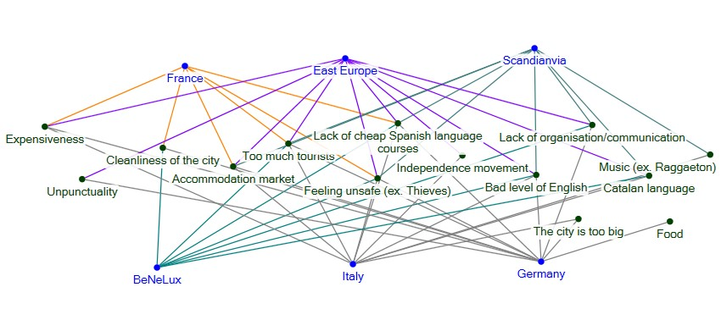

Figure 3: Visual representation of the initial bi-partite network: “what do you dislike about the city since you came here” (Dislikes)

## The initial undirected bi-partite network was separated in a Co-citation-network and a network with bibliographic coupling *(Figure 4)*. The Co-citation-network shows the regions as nodes and the edges display the connection regarding to the matching answers. Whereas in the network with bibliographic coupling the answers are presented as nodes and edges display the connection between answers. Furthermore, to keep the overview both networks are separated again for Likes and Dislikes.

Figure : Separation of the network

## Degree centrality [2]

The degree measures the number (i) of all edges that are connected to one node (ki). In the present paper, only undirected networks are analysed therefore every node has only one degree. In a network with n nodes the degree can be written as the following in the adjacency (Aij) matrix:

$$k_{i}=\sum_{j=1}^{n}{A_{ij}}$$

The individual degrees can be used to calculate the mean degree and the density of the network. The mean degree <k> is calculated as the following and provides information about the average degree in the network with m edges:

$$〈k〉 = \frac{1}{n}\sum_{i=1}^{n}{k_{i}}=\frac{2m}{n}$$

Using the mean degree, it is possible to calculate the density of the network which gives an impression of the relation between numbers of edges to nodes:

$$ρ=\frac{m}{\left(\begin{matrix}n \\ 2\end{matrix}\right)}=\frac{2m}{n(n-1)}=\frac{〈k〉}{n-1}$$

## Closeness centrality [2]

The closeness centrality (ci) of a node is the inverse of its mean geodesic distance (li) which is calculated by determining all geodesic paths a node has in a network. A geodesic path describes the length (d) of the shortest way between node (i) and node (j) by counting the number of edges. All present nodes divided by the sum of all geodesic paths determines the closeness centrality of an individual node:

$$c_{i}=\frac{1}{l_{i}}=\frac{n}{\sum_{j}{d_{ij}}}$$

## Betweenness centrality [2]

The betweenness centrality (xi) of a node i is determined by counting the geodesic paths (nist) that include the analysed node i on its way from node s to t. It displays the centrality of a node in a different way as it counts nist = 1 for a geodesic path passing the analysed node and nist = 0 if not. The value can be normalized by dividing it by the total amount (gst) of geodesic paths:

$$x_{i}=\sum_{st}{n_{ st}^{i}};normalized: x_{i}=\sum_{st}{\frac{n_{ st}^{i}}{g_{st}}}$$

# Analysis and Results

# Likes

We will start analysing the network of answers regarding to their connection between each other *(Figure 5).* In other words, a connection between two answers is strong if more participants choose these answers together and vice versa. To understand the connections, we additionally look at the answers of the regions and compare the percentages. If in a region more than 50 % choose an answer as a reason why they came to Barcelona it is interpreted as a positive connection, below it is negative.

Looking at the data it is eye-catching that all regions chose “Good weather” and “Big city” to be a reason to come to Barcelona and “Catalan culture”, “Sports”, “FC Barcelona” and “Particular subjects in Uni” are not. Therefore, the latter do not appear in Figure 5. “Good weather” with the maximum degree of six, maximum Betweenness of 10,5 and a Closeness of 0,167 can be labelled as the hub in the presented network *(Figure 5).*

Four out of five French participants agree that “Dance” is one reasons they choose Barcelona. In all other regions combined there is only one participant from East Europe that agrees with the French. That’s why in Figure 5 we can see that “Dance” and “Music” share a strong connection but are isolated from the other part of the network. The same degree can be seen for “Clubs/party” in which all participants from BeNeLux agree with 83 % of the French. Geographically these two regions share boarders which can influence the connection. The other regions agree with an average of only 21 %.

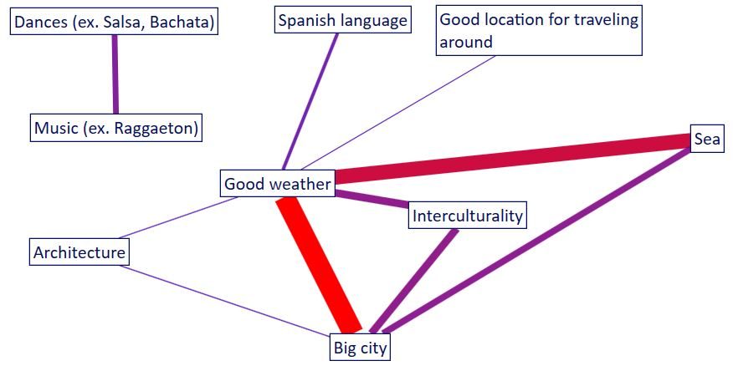

Figure 5: Network of answers (*Likes*) regarding to connections by regions

|  |  |  |  |
| --- | --- | --- | --- |
|  | Degree | Betweenness | Closeness |
| Minimum | 1 | 0 | 0,091 |
| Maximum | 6 | 10,5 | 1 |
| Average | 2,222 | 1,333 | 0,308 |

Approaching another answer which is addressed to the “Liberality”, 50 % of the East European participants like this and see it as a reason why they came to Barcelona. Other regions like BeNeLux, Germany and Italy agree with less than 20 %. While Scandinavian and French participants agree with around 30 %. However, the strongest agreement embodied by the participants of East Europe may be connected to the political situation in eastern states and more liberal politics in western regions.

The highest agreement with “Architecture” is shown by Scandinavian participants with 86 % followed by Germany and the other regions with 50 % to 17 %. Because Scandinavian participants, as well as almost all others, choose “Good weather” and “Big city” as a reason to come to Barcelona, “Architecture” appears in Figure 5.

Our second network analysing the *Likes* has six nodes that represent the regions *(Figure 6).* Edges are stronger if participants from different regions agree on the same answers. The strongest connection is displayed between the region of BeNeLux and France as the second strongest is between BeNeLux and Germany. Whereas the connection between Germany and France is relatively weak.

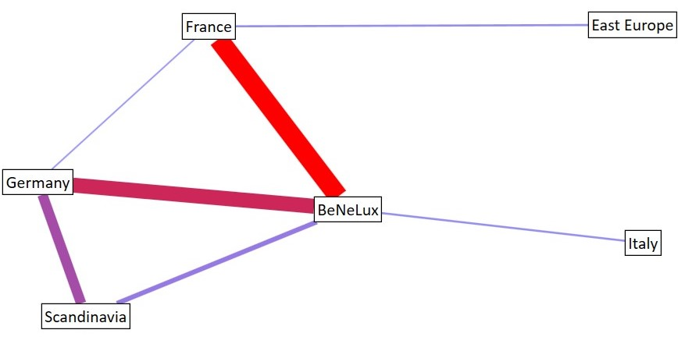

Figure 6: Network of regions regarding to *Likes*

|  |  |  |  |
| --- | --- | --- | --- |
|  | Degree | Betweenness | Closeness |
| Minimum | 1 | 0 | 0,091 |
| Maximum | 4 | 5 | 0,167 |
| Average | 2,333 | 1,667 | 0,126 |

For analysing the network, we set up a limit for the edge weight of 440 to highlight the main connections. BeNeLux shows the maximum degree of four, maximum betweenness of five and the maximum closeness of 0,167 in the presented network. Therefore, BeNeLux can be labelled as the network´s hub. The second strongest node is France with a degree of three, betweenness and centrality of four and 0,143.

Italy, Scandinavia and Est Europe have a betweenness of zero which means there is no geodesic path passing through them. Moreover, Italy and East Europe have the minimum degree of one but the closeness centrality of Italy with 0,1 is slightly higher than East Europe´s with 0,09. This can be attributed to the hub BeNeLux to which Italy is connected and therefore makes it closer to the other nodes than East Europe´s connection to the weaker node of France.

## Dislikes

Analyzing the data obtained on the network Dislikes as “Temperature”, “Interculturality”, “Public transport”, we see that answers are absent, and more than 50% respondents worried about “Feeling unsafe”.

Another answer that most Germans chose was the “Lack of organization”, that partly confirms some of the habits inherent in this country. More than 50% respondents from East Europe noted the “Expensiveness” of living in Barcelona. Complaints about “Unpunctuality”, “Cleanlieness”, “Food” were not popular.

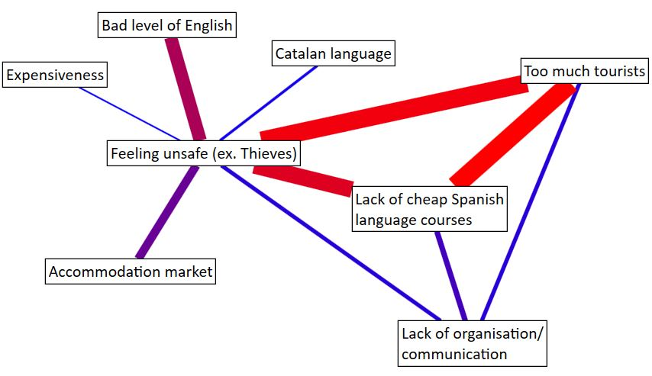

Figure 7: Network of answers (Dislike) regarding to connections by regions

|  |  |  |  |
| --- | --- | --- | --- |
|  | Degree | Betweenness | Closeness |
| Minimum | 1 | 0 | 0,077 |
| Maximum | 7 | 18 | 0,143 |
| Average | 2,5 | 2,25 | 0,09 |

For analysing this network, we set up a limit for the edge weight of 330 to highlight the main connections *(Figure 7).* There are maximum degree is seven, maximum betweenness is eighteen and the maximum closeness is 0,143 in the presented network. Such answers as “Feeling unsafe” we can be labelled as the network´s hub. The next strongest node is “Lack of cheap Spanish language courses” and “Too much tourists”.

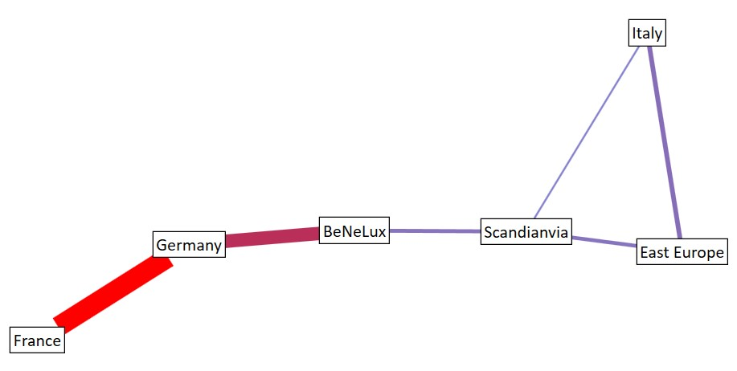

Figure 8: Network of regions regarding to *Dislikes*

|  |  |  |  |
| --- | --- | --- | --- |
|  | Degree | Betweenness | Closeness |
| Minimum | 1 | 0 | 0,071 |
| Maximum | 3 | 6 | 0,125 |
| Average | 2 | 2,667 | 0,101 |

For analysing this network, we set up a limit for the edge weight of 295 to highlight the main connections *(Figure 8).* There are maximum degree is three, maximum betweenness is six and the maximum closeness is 0,125 in the presented network. The strongest connection between France and Germany, more than 50% respondents from these countries did not like “Too much tourists”, also it turned out to be very important for Germany “Lack of cheap Spanish courses”, for others it amounted to 20%.

# Conclusion

Despite the fact that initially a survey of students was conducted in accordance with the country of residence and for data analysis it was necessary to combine the answers according to the region of residence, the considered NodeXL models give an idea of ​​the countries with the largest number of similar answers and more strong connections, so in the case of the Like model: BeNeLux and France, and BeNeLux can be labelled as the network´s hub in the case of the model Dislikes: Germany and France have a strongest connection and hub is Scandinavia. Respondents from all regions chose “Good weather” and “Big city” to be a reason to come to Barcelona and what is surprising, are not selected “Catalan culture”, “Sports”, “FC Barcelona” (that typical in Spain) and “Particular subjects in Uni” are not. The main disappointments regarding Barcelona were about “Feeling unsafe”, “Lack of cheap Spanish language courses” and “Too much tourists”.

The analysis is useful for determining the most popular places for study, as well as for displaying the current situation in the city, this data can be interesting both for organizations that provide students with the opportunity to study abroad and host universities. But for further research, it would be interesting to conduct a survey among a larger number of respondents to obtain more accurate results.

# References

[1] Newman, M.E.J. (2010). Networks: An Introduction

[2] Rosas-Casals M. (2017): Fundamentals of network theory. Complex and Socio-Environmental Networks. Summ Lab UPC. Barcelona, 2017.