**Multiphase flows though porous structures**

Summary of work:

Chemical industries are always in search of new supports for catalyst deposition to improve the energy efficiency of the chemical process. Metallic and ceramic foam packing, due to their high porosity, high specific surface area and low pressure drop are promising alternatives for packing internals used in chemical engineering processes. There are not many work performed with ceramic foams as reactor internal using CFD. It is also very tedious to characterize the structural parameters of ceramic foams. Ceramic foams with different pore density are analyzed using MRI technique and characterized for different geometrical parameters. There are few works available in the literature with ceramic foams as reactor internals using experimental technique. Few empirical equations have been proposed for the same. These empirical equations will be studied in detail and validated with in house experiments performed using X-ray tomographic studies.Although, there are many closures available for trickle bed reactor studies where spherical particles are considered as reactor internals. A 3D CFD simulation of the evolving gas-liquid flow patterns in trickle bed reactors is performed and the results are validated with experiments Marcandelli et. al., (2000). Further these closures are extended for ceramic foams studies and are validated with experimental X-ray tomographic studies.

A two-phase Eulerian model is used considering the flow domain as porous. The geometric specifications and experimental data are inspired from Marcandelli et. al., (2000).

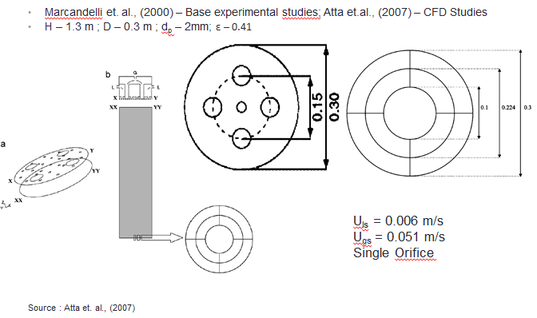

*Fig 1. Geometry of Trickle bed reactor*

Following are the hypothesis made for numerica analysis:

* Co-current downward flow of gas and liquid. (Here: Air and Water)
* No interphase mass transfer.
* Flowing fluids - incompressible.
* Porous medium - Isotropic i.e. permeabilities are independent of direction.
* Porosity distribution - Mueller‘s correlation (Mueller, G.E, 1990)
* Operaing flow regime - Trickle
* Capillary pressure is neglected
* Contribution of turbulent stress terms to overall momentum balance equations is not significant. (e.g. Jiang et al., 2002a)

The influence of the liquid and gas (water and air) drag is added as external source terms to liquid and gas momentum equations separately. The drag forces between the phases have been taken into account using the relative permeability approach, which was developed by Saez and Carbonell (1985) and Fluid-Fluid model developed by Attou and Forschneider (1999). Relative permeability makes use of permeability concept between the two phases, whereas, two fluid model makes use of saturation of each phase in finding out the drag force between three phases. The use of coupled terms makes it easier to simulate the drag force and coefficient of drag.

Momentum balance equation:

$ρ_{α}\left(\frac{∂u_{α}}{∂t}+u_{α}.∇u_{α}\right)=-\left(∇p_{α}-ρ_{α}g\right)+∇.\left(τ_{α}+R_{α}\right)+F_{α}$; $α=g,l$

1. RELATIVE PERMEABILITY MODEL:

Total drag force per unit of bed volume: (Saez and Carbonell, 1985)



Equivalent diameter:



Permeability correlations in terms of saturation in liquid phase:



Static Liquid hold up:



1. TWO FLUID MODEL:

Interface coupling terms: (Attou and Forschneider, 1999):

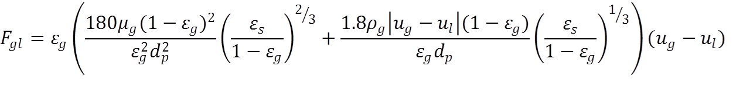





|  |  |
| --- | --- |
| Where, | |
| $F_{α}$ = | Total drag force per unit bed volume exerted by phase $α$ |
| $A$ = | 180 |
| $B$ = | 1.8 |
| $k_{α}$ = | Permeability of $α$ phase |
| $μ_{α}$ = | Viscosities of $α$ phase |
| $ρ_{α}$ = | Density of $α$ phase |
| $u_{α}$ = | Superficial velocity of $α$ phase |
| $d_{p}$ = | Particle diameter |
| $ε$ = | Porosity at any time |
| $ε_{l}$ = | Liquid hold up |
| $ε_{l}^{0}$ = | Static liquid hold up |
| ${Eo}^{*}$ = | Eötvös number |
| $σ_{l}$ = | Surface tension of Liquid |

MAL DISTRIBUTION FACTOR: (Mf)



Where, N= Number of zones at outlet

$Q_{Li}$ = Liquid flow rate through zone i

$Q_{mean=}$ mean flow rate ()

* + Mf varies from 0 to 1.
  + Lower the value of Mf, better is the distribution

The advantages and disadvantages of both the closures are studied in detail.

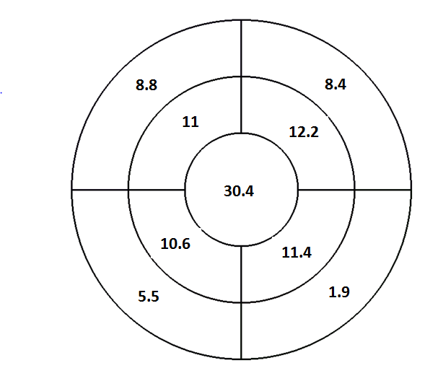

*Fig 2. Experiment result for Liq. Saturation at outlet (Marcendelli,1999)*

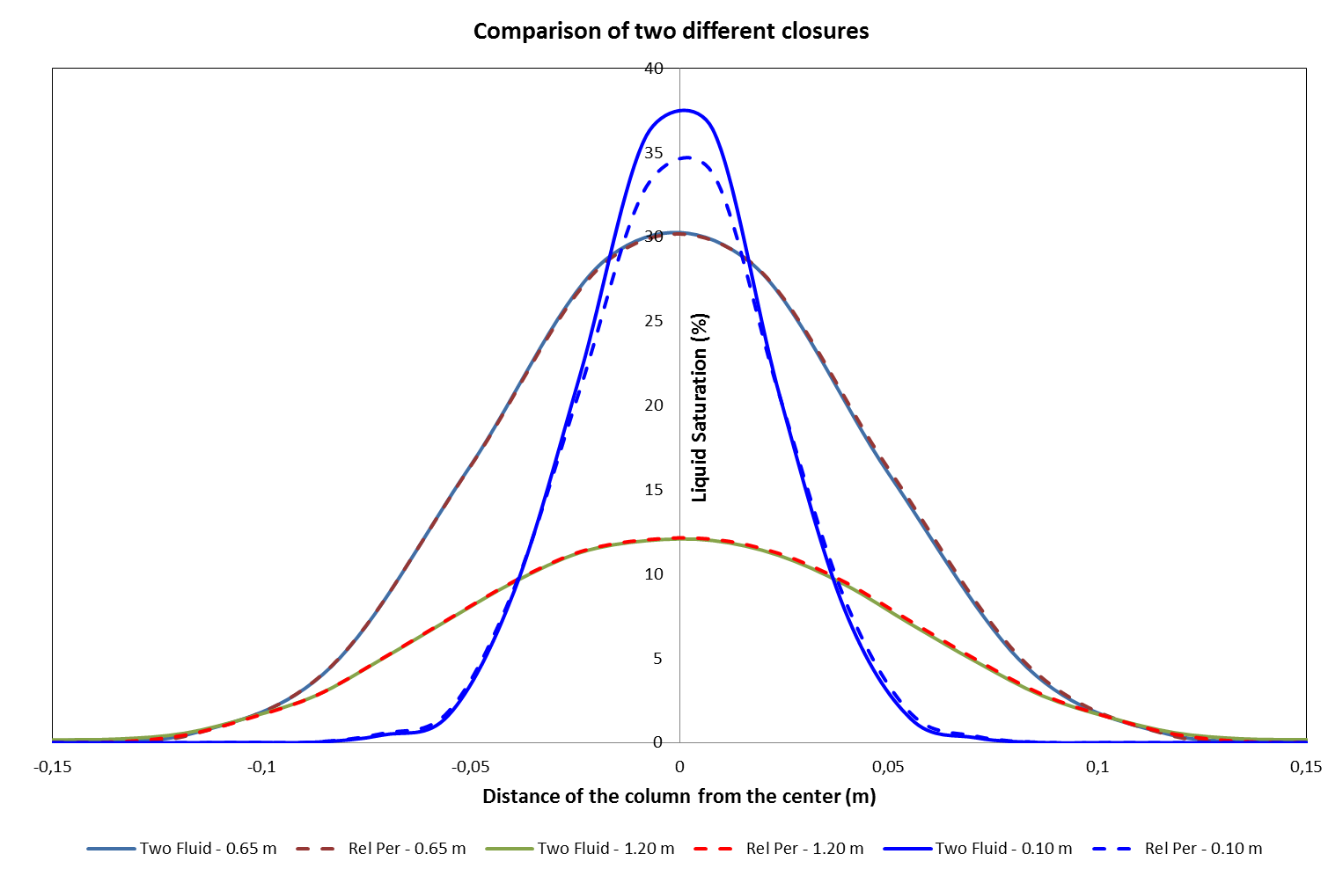

*Fig. 3. Graph of for Liq. Saturation at outlet by both closures (this work)*

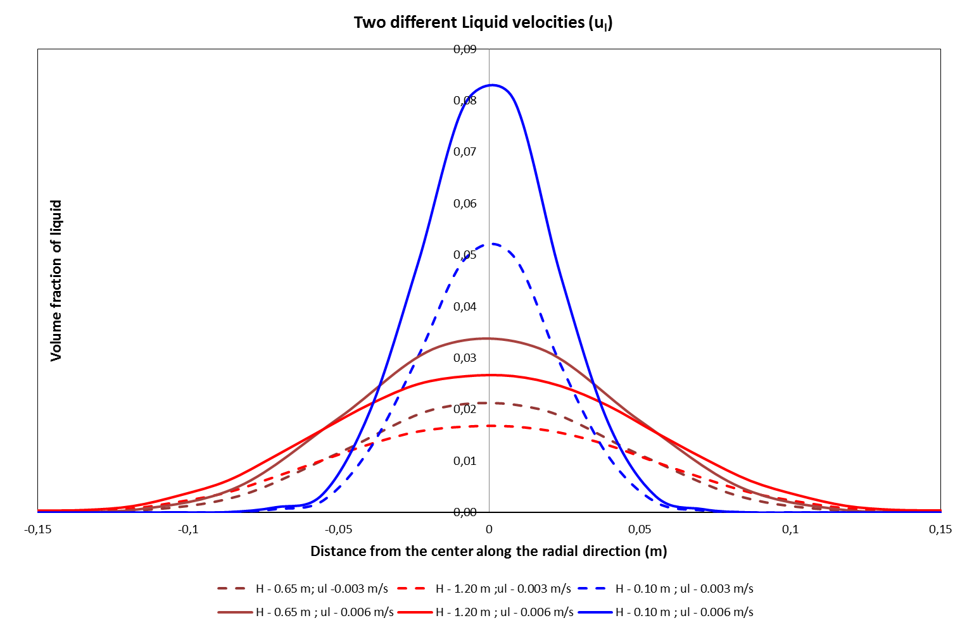

*Fig 5. Graph of voume fraction at different velocities by both closures (this work)*

The major hydrodynamic parameters such as dynamic liquid holdup, liquid distribution at different heights of the column, pressure drop are studied and validated with experimental studies. The comparison is made in terms of percentage distribution by calculating the mal-distribution factor with the experiment Marcendelli et. Al. (2000). A robust model is formulated for implementation and analysis in pilot scale foam studies. The flow behaviour is in good agreement between experiments and simulations. There is a possibility to improve the radial distribution of the liquid flow. The closures for the dispersion forces will be further included in order to improve the agreement and accuracy of the simulation. These closures will be further modified to study the liquid flow behaviour in the reactor with solid ceramic foams as internals.