**BFS_ SVG_ EXP_MSF_NUAA**

**Skin friction**

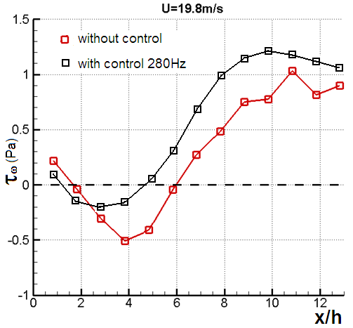

|  |  |
| --- | --- |
| **X(h)** | （Pa） |
| 1 | 0.1 |
| 2 | -0.15 |
| 3 | -0.2 |
| 4 | -0.16 |
| 5 | 0.05 |
| 6 | 0.3 |
| 7 | 0.7 |
| 8 | 1 |
| 9 | 1.13 |
| 10 | 1.2 |
| 11 | 1.17 |
| 12 | 1.12 |
| 13 | 1.07 |