BFS_ MS_ EXP_MSF_NUAA
Micro suction
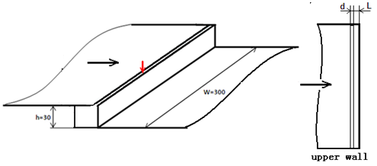
L: distance from step d: width of slot
Experimental curves: skin friction(Pa)
L=1mm, d=1mm
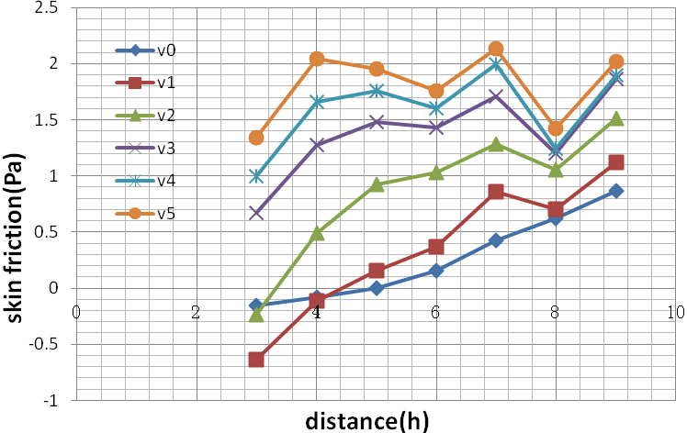

L=8mm, d=1mm
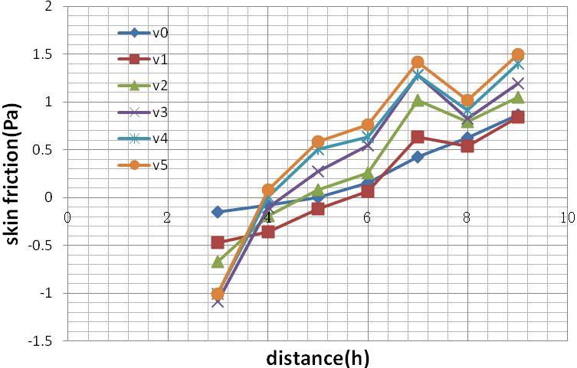
BFS_ MS_ EXP_MSF_NUAA
Micro suction
Experimental data: skin friction(Pa)
L=1mm, d=1mm

 | v0=0 | v1=7.91 | v2=17.63 | v3=26.16 | v4=34.30 | v5=42.08
3h | -0.15 | -0.63 | -0.24 | 0.67 | 0.99 | 1.34
4h | -0.07 | -0.11 | 0.49 | 1.27 | 1.66 | 2.04
5h | -0.002 | 0.16 | 0.92 | 1.48 | 1.76 | 1.95
6h | 0.15 | 0.37 | 1.03 | 1.43 | 1.60 | 1.76
7h | 0.43 | 0.85 | 1.28 | 1.71 | 1.99 | 2.14
8h | 0.62 | 0.71 | 1.06 | 1.20 | 1.24 | 1.42
9h | 0.87 | 1.11 | 1.51 | 1.86 | 1.90 | 2.02

L=8mm, d=1mm
 | v0=0 | v1=7.77 | v2=16.94 | v3=25.15 | v4=33.02 | v5=40.40
3h | -0.15 | -0.47 | -0.67 | -1.08 | -1.00 | -1.00
4h | -0.07 | -0.35 | -0.19 | -0.10 | 0.01 | 0.08
5h | -0.002 | -0.12 | 0.08 | 0.27 | 0.50 | 0.58
6h | 0.15 | 0.06 | 0.26 | 0.55 | 0.63 | 0.76
7h | 0.43 | 0.63 | 1.01 | 1.28 | 1.28 | 1.42
8h | 0.62 | 0.53 | 0.79 | 0.83 | 0.91 | 1.02
9h | 0.87 | 0.84 | 1.05 | 1.20 | 1.40 | 1.50

