**Homework 1**

Isperih Daulov, Kim Sungchul, Carlos Moreira

**Exercise 2**

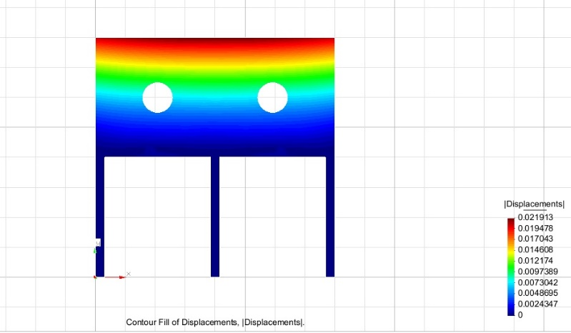

**Fig.1 Displacement total**

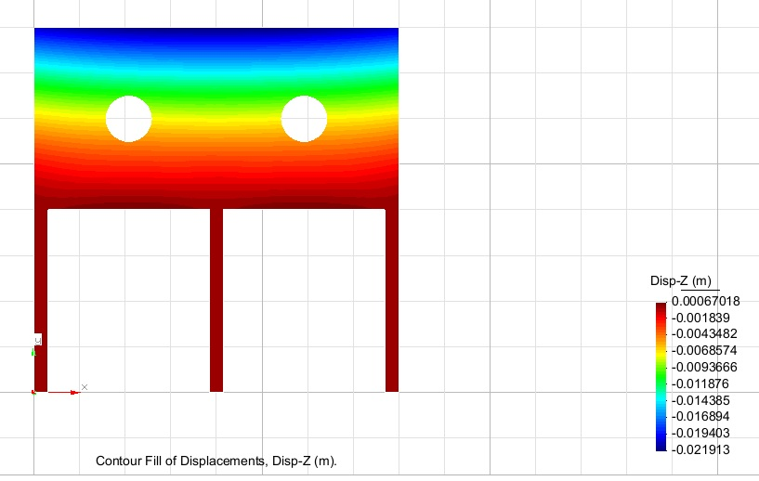

**Fig.2 Displacement in Z direction**

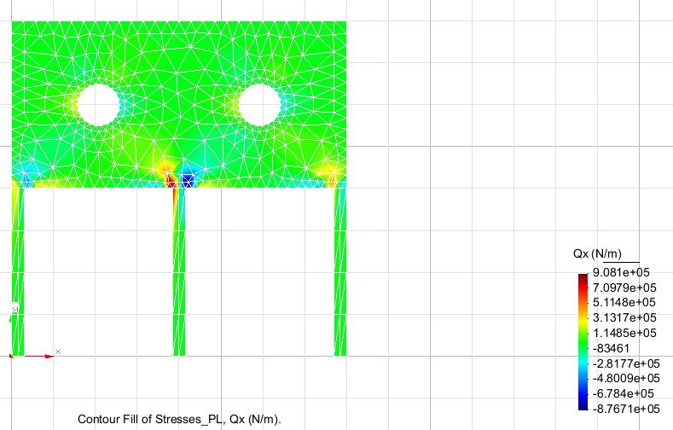

**Fig. 3 Stress in x direction**

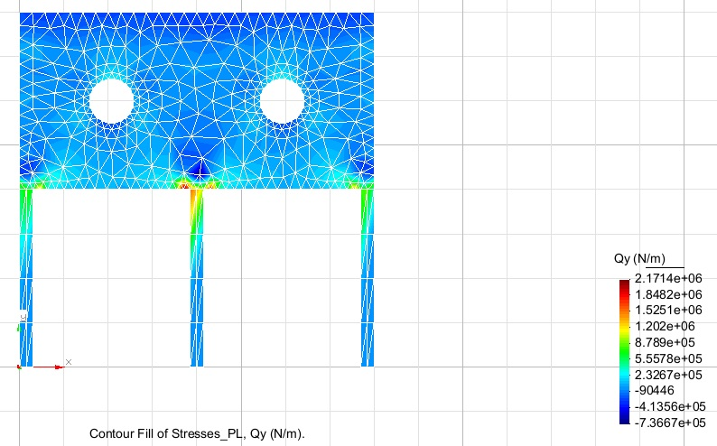

**Fig. 4 Stress in y direction**

**Exercise 3**

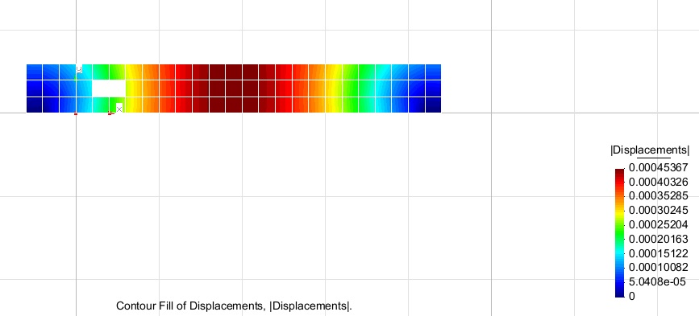

**Fig.5 Displacement**

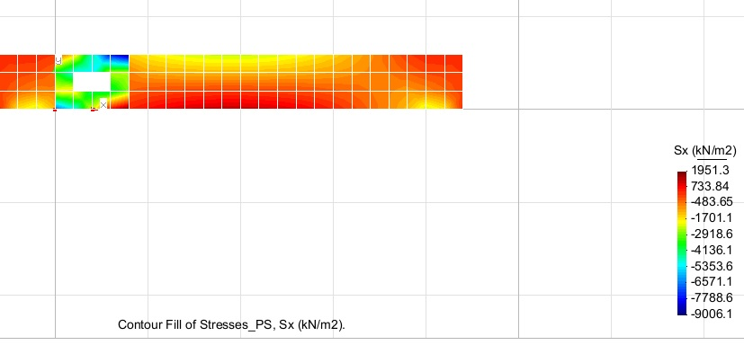

**Fig.6 Stress in x direction**

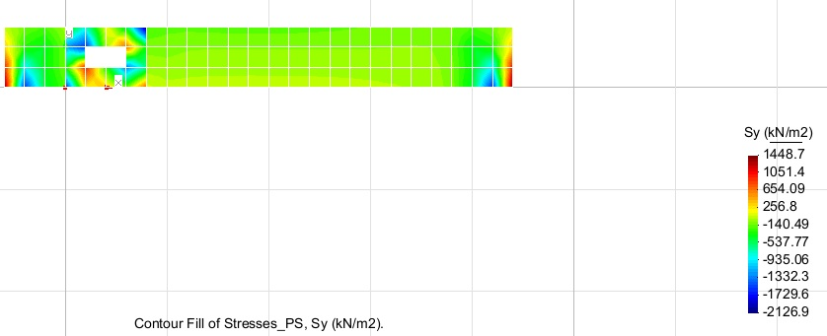

**Fig.7 Stress in y direction**

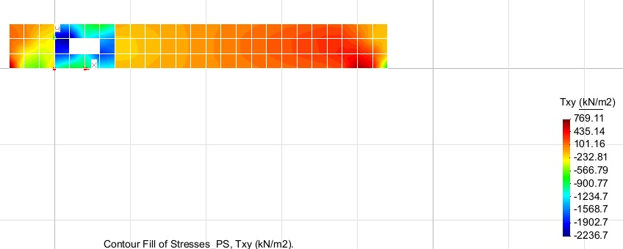

**Fig.8 Total stress**

**Exercise 4**

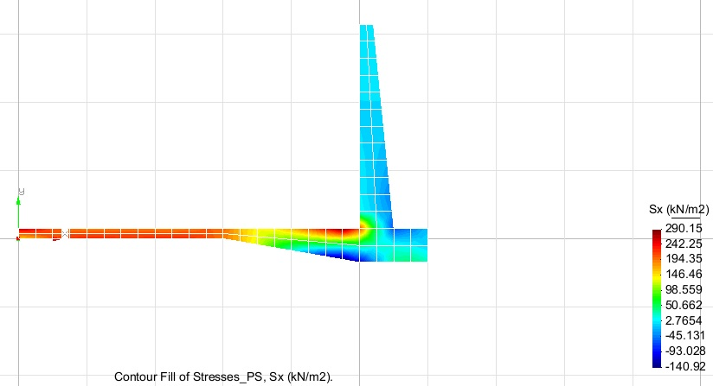

**Fig. 9 Stress in x direction**

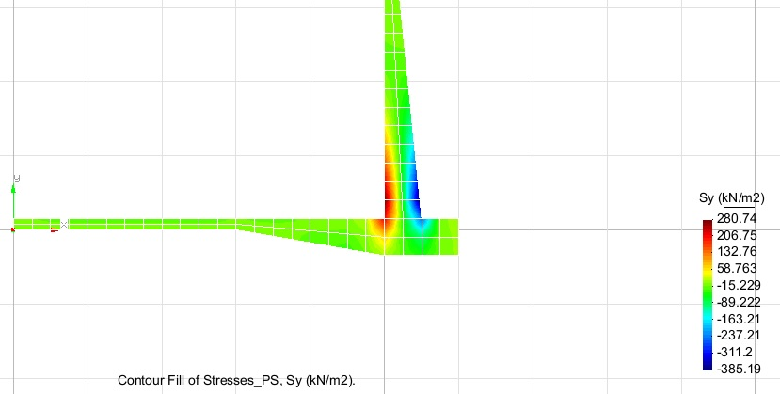

**Fig. 10 Stress in y direction**

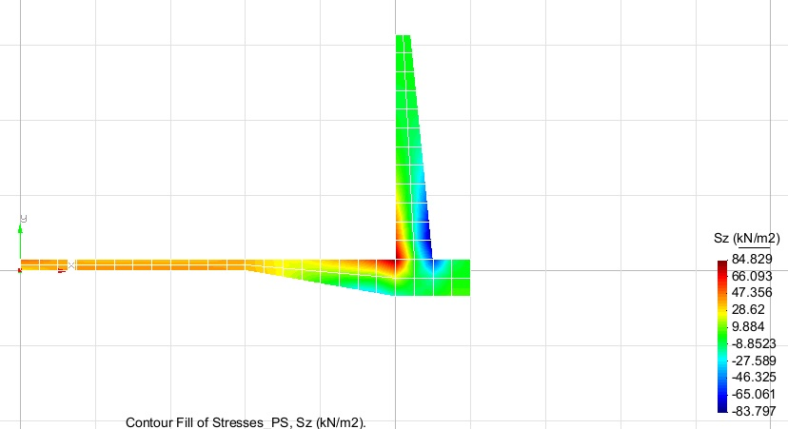

**Fig.11 Stress in z direction**

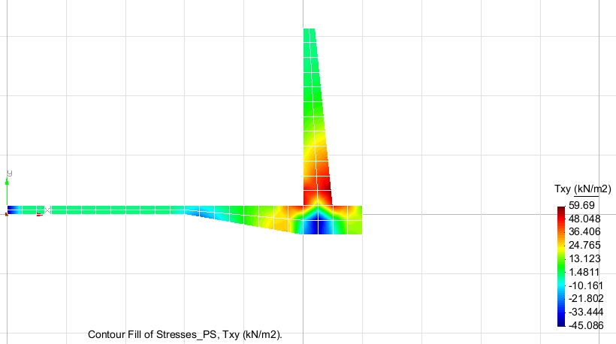

**Fig. 12 Total Stress**

**Analysis**

In exercise 2 we observe that the stress in the middle column is bigger in x direction. However, the margin of highest stressed point and the lowest is bigger in z direction it`s equal to -13.5416. And in x direction is 0.8532.

In exercise 3 the stress in the x direction is bigger than the stress in y direction. The stress in x direction is big all around the plate, however it is less stressed around the hole. The main stress distribution goes over the hole plate with less going around the ventilation hole.

In exercise 4 the main stress goes in the bottom of the retaining wall with the biggest part of the stress going into the outer layer of the wall. And with less stress going up on the retaining wall and away from it on the soil.