Homework 2

By

Carlos Moreira, Isperih Daulov, Sungchul Kim

Q1

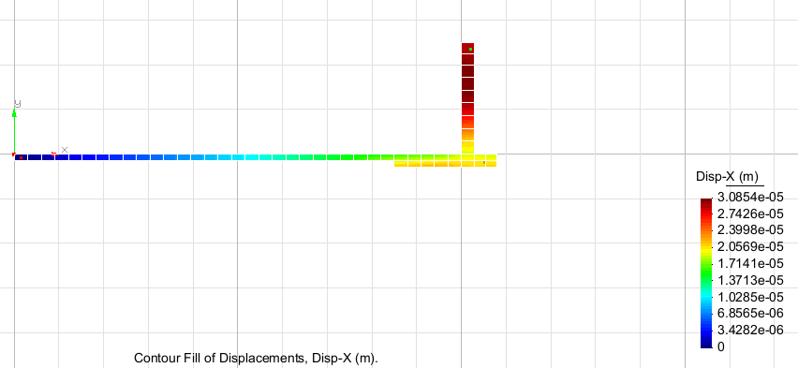

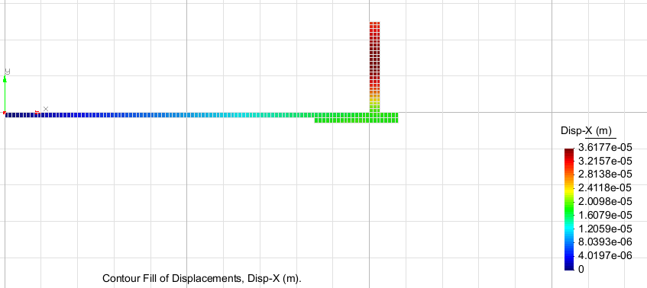

Finer mesh

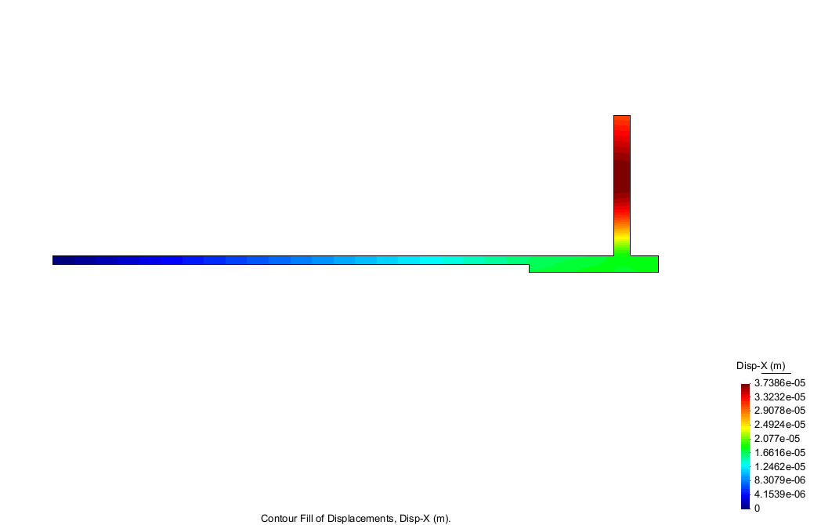

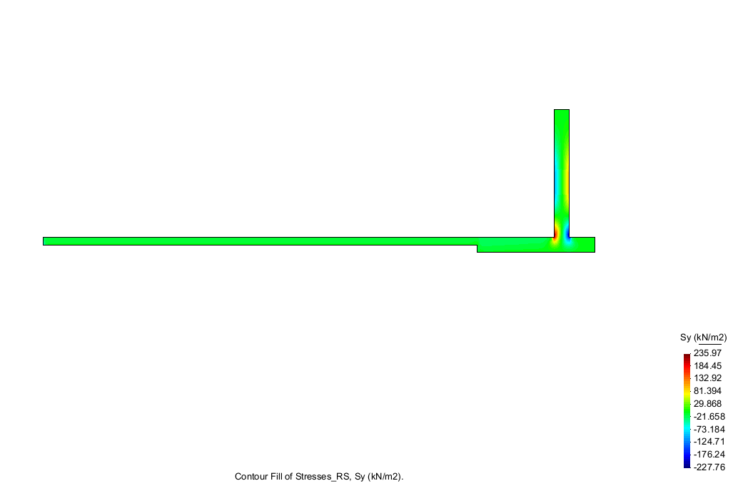

Analysis: The finer the meshes get it results in bigger displacements.

The max stress applied on the structure is 235.97kN/m^2 and the minimum is -227.76 in Sy direction.

Ex 2

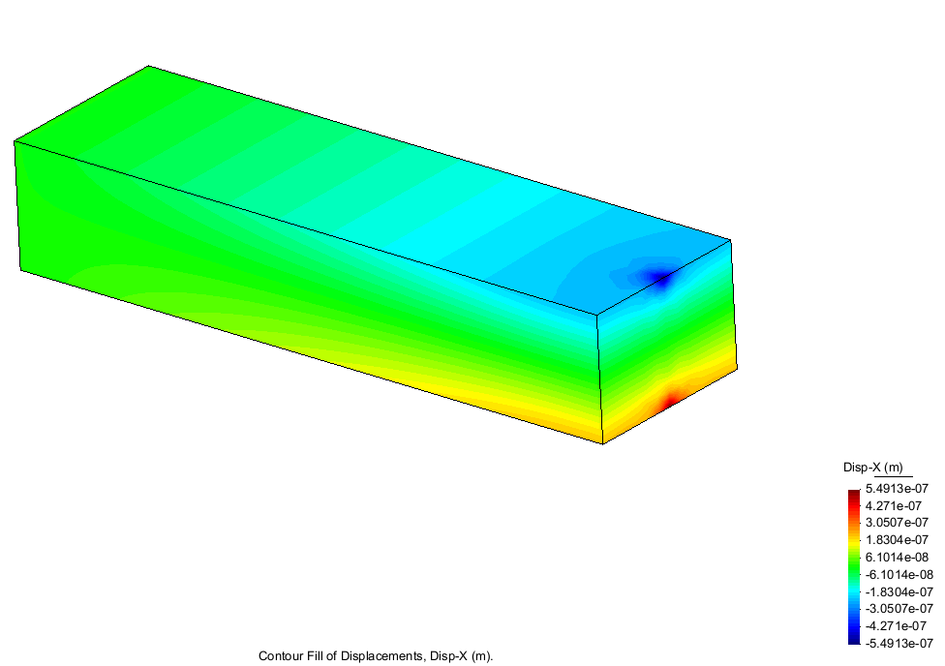

8nodes displacements in x direction

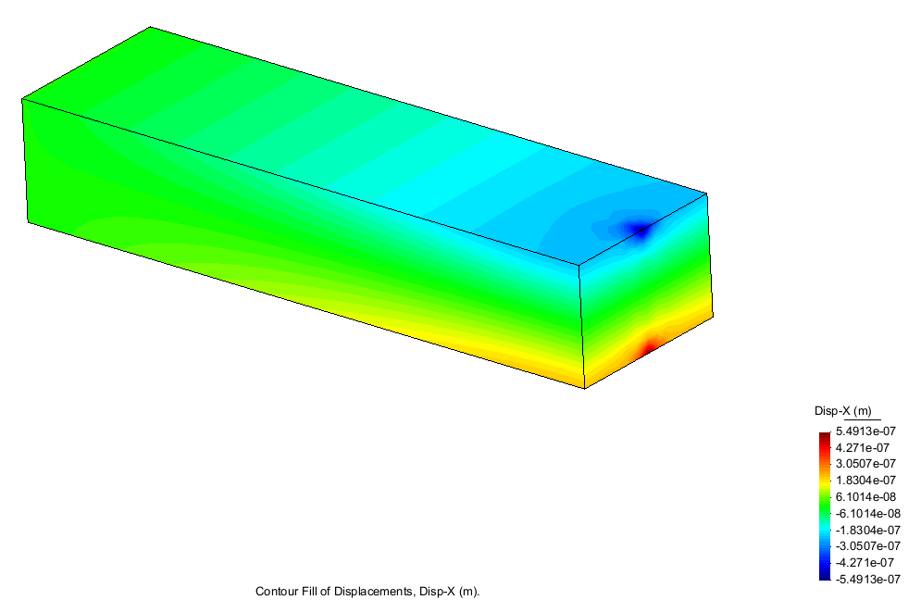

20 nodes displacements in x direction

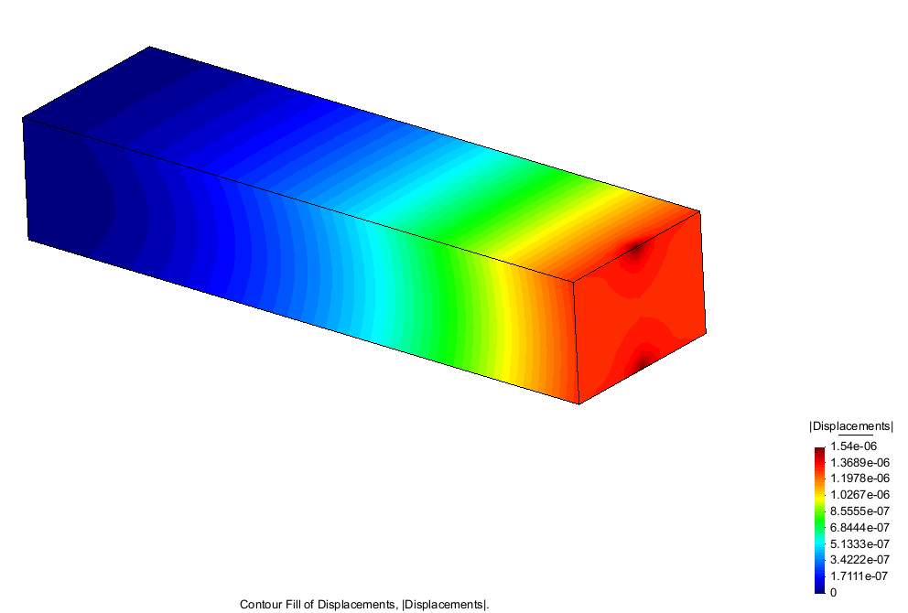

8 nodes total displacements

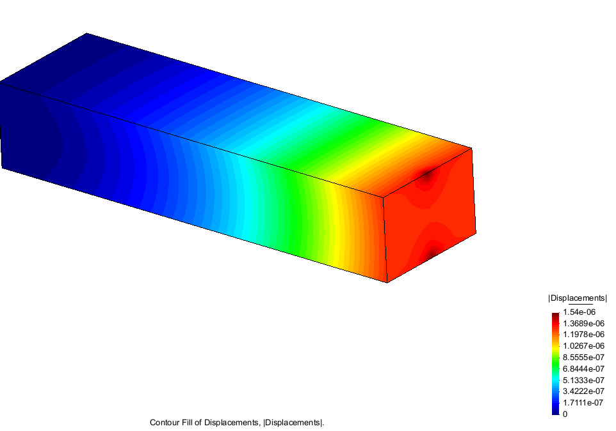

20 nodes total displacements

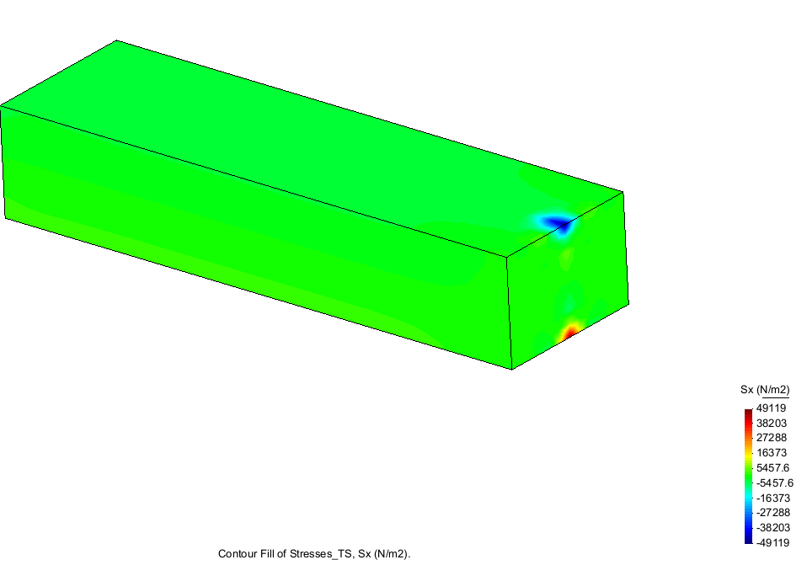

8 nodes Stress in Sx

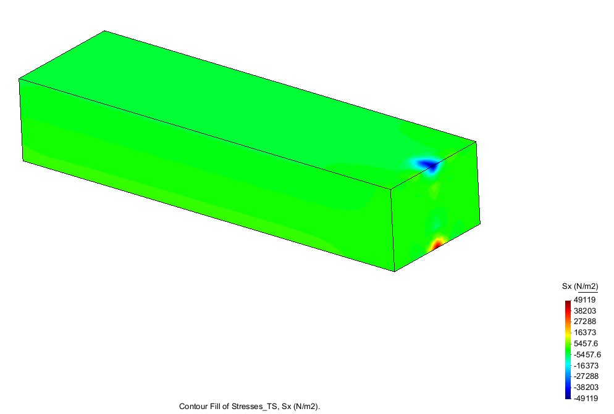

20 nodes stress in Sx

Analysis: The results using 8 node and 20 node hexahedra elements are the same.

Ex. 3

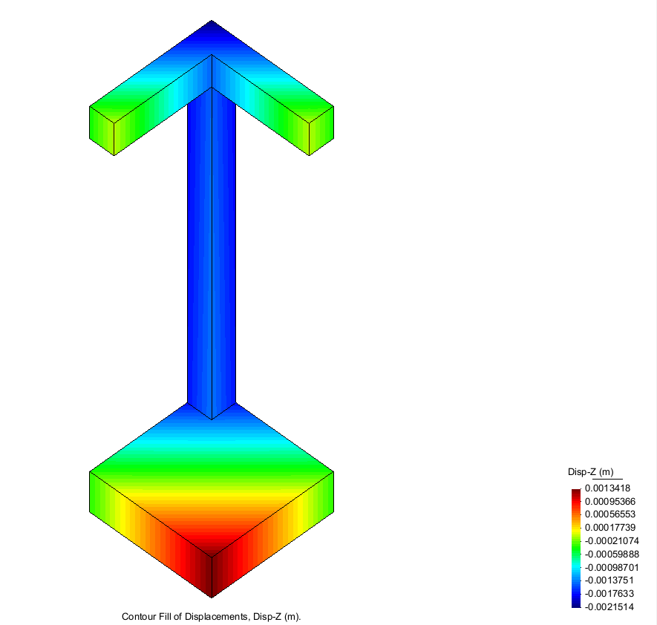 no soil

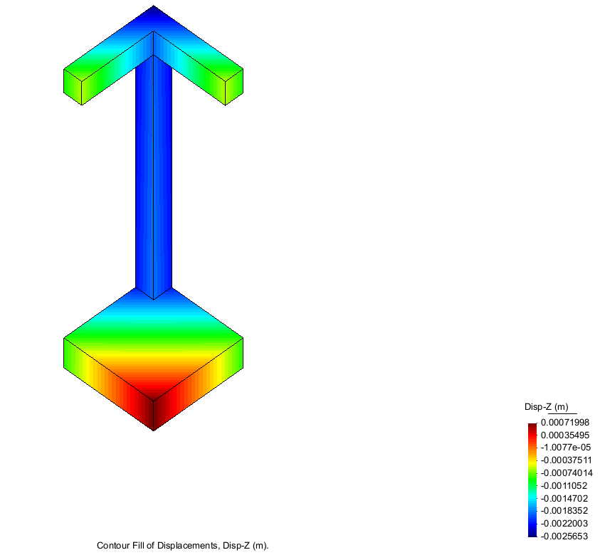soil

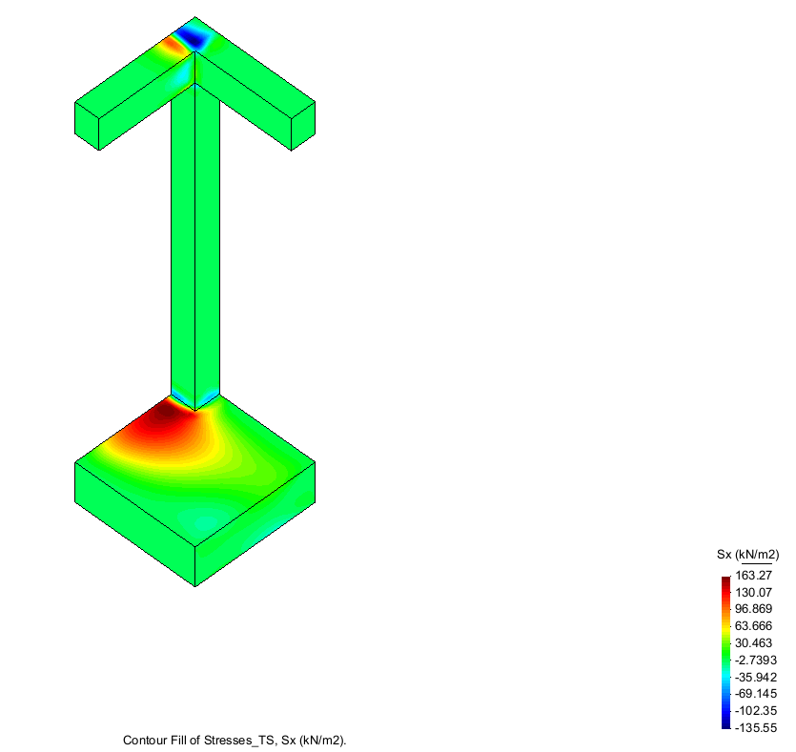no soil

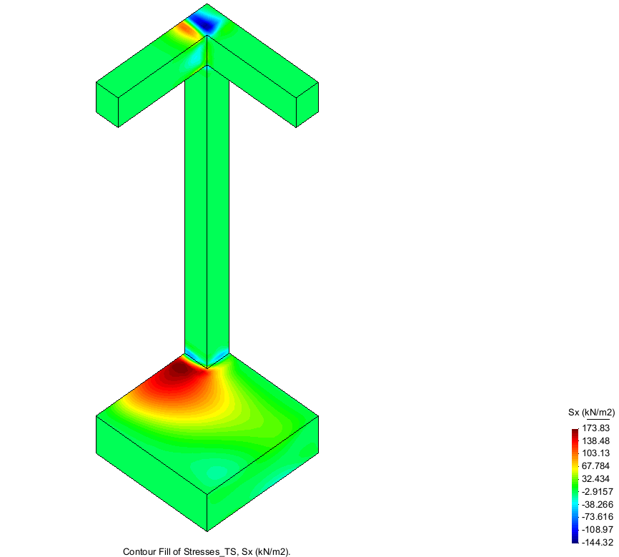soil

Analysis: In the no soil examples Lifting does not occur. And results are smaller than the Soil ones where lifting does occur.