Practice 5

By

Carlos Moreira, Isperih Daulov, Sungchul Kim

Ex1

Natural Frequency = 1

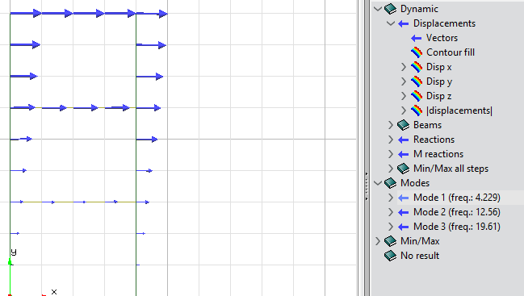mode1

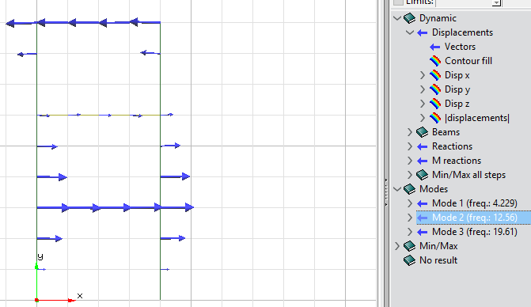

Mode 2

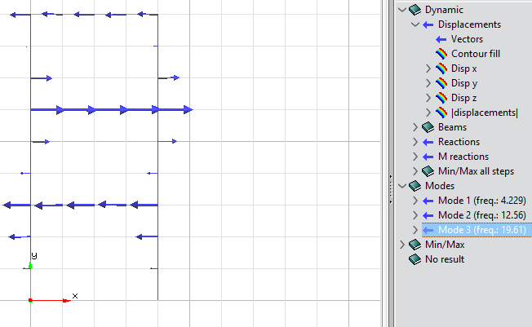mode 3

All 3 modes remain the same for the different models

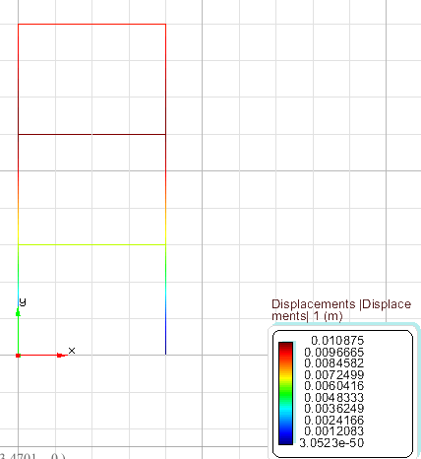Displacements

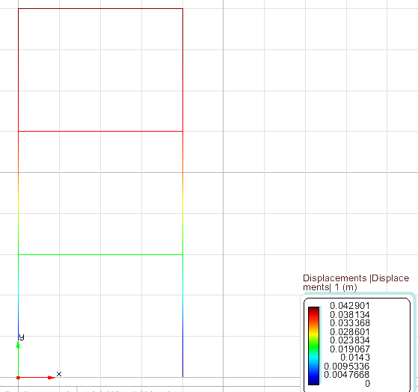Obtained from the Direct integration.

Natural Frequency= 0.75

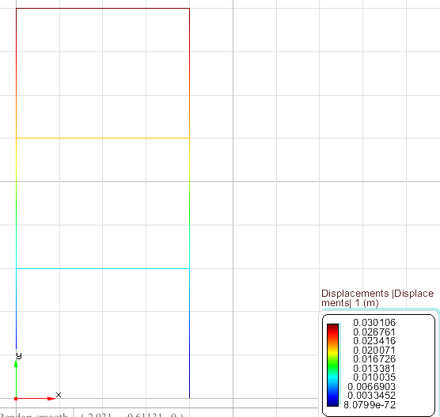Displacements

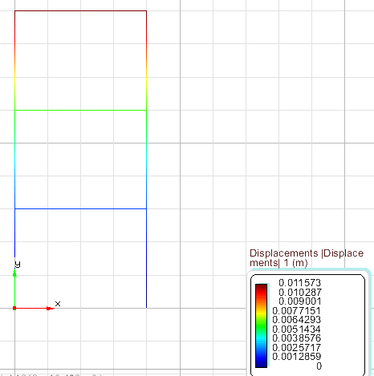Obtained from Direct integartion

Natural Frequency= 1.25

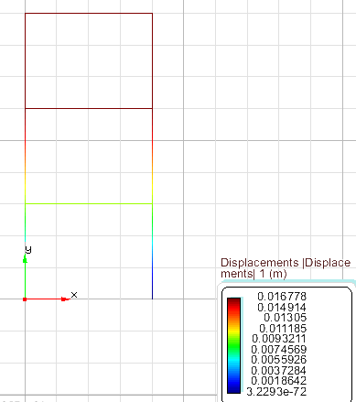Displacements

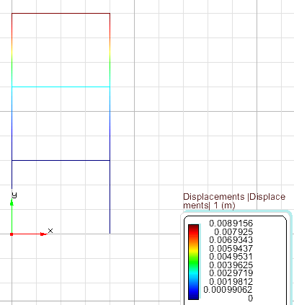Obtained from Direct integration

Analysis: In the direct integration method the maximum displacement is higher and minimum is equal to 0.

Ex2.

10 modes

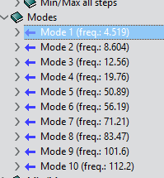

Mode 1

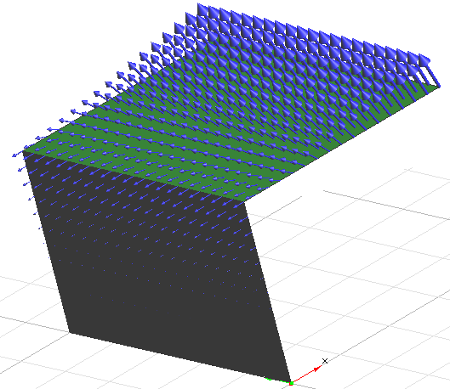

Mode 2

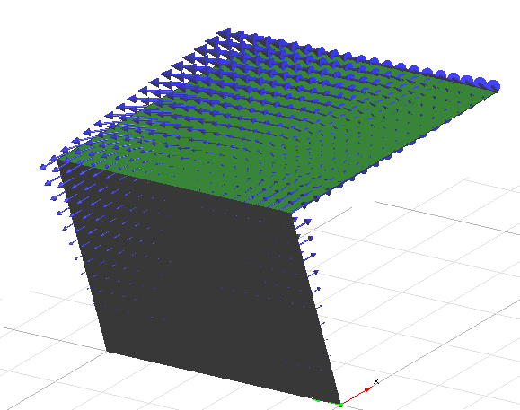

Mode 5

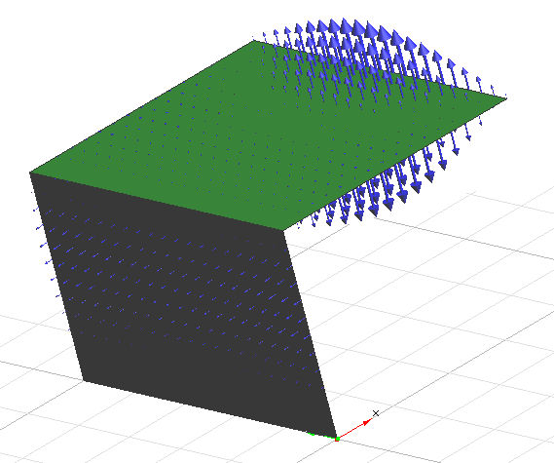

Mode 7

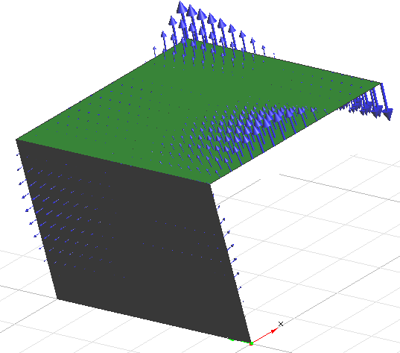

Mode 10

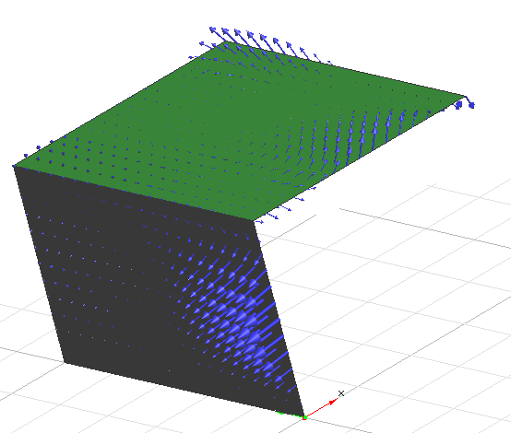

A problem in the work files occurred unable to collect the other data.